# **VISVESVARAYA TECHNOLOGICAL UNIVERSITY**

# "Jnana Sangama", Belgaum -590 018, Karnataka State, India

A MINI PROJECT REPORT

ON

**“GENERAL STORE MANAGEMENT SYSTEM”**

Submitted on partial fulfilment of academic requirement of 5th semester

**BACHELOR OF ENGINEERING**

**IN**

**COMPUTER SCIENCE AND ENGINEERING**

**Submitted by**

**VINAYTEJ VG USN:1SJ19CS169**

**VIJAY RJ USN:1SJ19CS165**

.

V SEM, CSE C

**Under the guidance of**

**Mr. PRADEEP KUMAR G M**

Assistant Professor,

Department of CSE, SJCIT

**Carried out**

**at**

**DATABASE MANAGEMENT SYSTEM LABORATORY,**

**SJCIT**



**S J C INSTITUTE OF TECHNOLOGY**

**Department of Computer Science and Engineering**

**Chickaballapur – 562 101**

**2019-2020**

**|| Jai Sri Gurudev ||**

**Sri Adichunchanagiri Shikshana Trust**

**S.J.C INSTITUTE OF TECHNOLOGY**

**Computer Science & Engineering Department**

**Chickballapur-562101**



**CERTIFICATE**

This is to certify that the Project work entitled **“ GENERAL STORE MANAGEMENT SYSTEM”** is a bonafide work carried out at Database Management System Laboratory by VINAYTEJ VG(1SJ19CS169) and VIJAY RJ(1SJ19CS165)in partial fulfilment for the award of **Bachelor of Engineering in Computer Science and Engineering in Fifth semester of the Visvesvaraya Technological University**, Belgaum during the year 2019-20.It is certified that all corrections/suggestions indicated for Internal Assessment have been incorporated in the report deposited in the department library. The project report has been approved as it satisfies the academic requirements in respect to Fifth Semester Mini Project work prescribed for the said degree.

**Signature of the Guide Signature of the HOD**

**Mr. Pradeep Kumar G M Dr.Manjunatha Kumar BH**

**Assistant Professor, Professor and HOD,**

**Department of CS&E, SJCIT Department of CS&E, SJCIT**

**External Viva:**

**Name of Examiners**

**1)**

**2)**

|  |
| --- |
| **ACKNOWLEDGEMENT**  With reverential pranam, we express our sincere gratitude and salutations to the feet of his holiness **Paramapoojya Jagadguru** **Byravaikya Padmabhushana Sri Sri Sri Dr. Balagangadharanatha Maha Swamiji,** his holiness **Paramapoojya Jagadguru Sri Sri Sri Dr. Nirmalanandanatha Maha Swamiji** and **Pramapoojya Sri Sri**Mangalnatha Swamiji , Sri Adichunchanagiri Mutt for their unlimited blessings.  First and foremost we wish to express our deep sincere feelings of gratitude to our institution, **Sri Jagadguru Chandrashekaranatha Swamiji Institute of Technology,** for providing us an opportunity for completing our DBMS miniproject successfully.  We extend deep sense of sincere gratitude to **Dr. G T Raju**, **Principal,S J C Institute of Technology, Chickballapur**, for providing an opportunity to complete the DBMS miniproject.  We extend special in-depth, heartfelt, and sincere gratitude to HOD **Dr. Manjunatha Kumar B H, Head of the Department, Computer Science and Engineering, S J C Institute of Technology, Chickballapur,** for his constant support and valuable guidance of the DBMS miniproject.  We convey our sincere thanks to Project Guide **Prof. PradeepKumar G M Assistant Professor, Department of Computer Science and Engineering, S J C Institute of Technology,** for his constant support, valuable guidance and suggestions of the DBMS miniproject.  We also thank all those who extended their support and co-operation while bringing out this DBMS miniproject report.  **VINAYTEJ VG 1SJ19CS169**  **VIJAY RJ 1SJ19CS165** |

|  |  |  |  |  |  |  |  |  |  |  |  |  |  |  |  |
| --- | --- | --- | --- | --- | --- | --- | --- | --- | --- | --- | --- | --- | --- | --- | --- |
| **ABSTRACT**  The system creates a form based interface that enables a shopkeeper/manager to maintain the products he sold based on the daily update of sales from its customer. Once the products are sold, the sold products are entered by the shopkeeper in the form that will display the sellings of products he sold. A shopkeeper can add the stock of the products from stock tab where he can include stock name, quantity etc.....  Once the quantity are given, the quantity will be placed with the required product cost which is fixed by shopkeeper. Once the products and quantity are entered in form, the products which are billed will be displayed when the view is clicked.  **LIST OF FIGURES**   |  |  |  | | --- | --- | --- | | Figure Number | Figure Name | Page | | Figure 5.1 | Admin Login Page | 19 | | Figure 5.2 | Main Billing Page | 20 | | Figure 5.3 | Updating Page | 20 | | Figure 5.4 | Adding Page | 21 |   **INDEX**  Acknowledgment  Abstract  Chapter 1: Introduction  Chapter 2: Literature Survey  Chapter 3: Hardware Software and Functional Requirements  Chapter 4: Analysis and Design  Chapter 5: Discussions & Snapshots  Chapter 6: Conclusion  Chapter 7: Bibliography |

**TABLE OF CONTENTS**

|  |  |
| --- | --- |
| Acknowledgement | i |
| Abstract | ii |
| List of figure | iii |
| Index | iv |

|  |  |  |
| --- | --- | --- |
| Chapter No. | Chapter Name | Page |
|  |  |  |
| Chapter 1: | Introduction |  |
| 1.1 | About your mini project |  |
| 1.2 | About SQL |  |
| 1.3 | Scope and application |  |
|  |  |  |
| Chapter 2: | Literature Survey |  |
| 2.1 | Related work |  |
| 2.2 | Problem Statement |  |
| 2.3 | Proposed Statement |  |
| 2.4 | Advantages and disadvantages |  |
|  |  |  |
| Chapter 3: | Hardware, Software and functional requirements |  |
| 3.1 | Hardware Requirements |  |
| 3.2 | Software Requirements |  |
| 3.3 | Functional Requirements |  |
|  |  |  |
| Chapter 4: | Analysis and design |  |
| 4.1 | Architecture of proposed systems |  |
| 4.2 | ER Diagram and Relational Diagram |  |
|  |  |  |
| Chapter 5: | Discussions and snapshots |  |
|  |  |  |
| Chapter 6: | Conclusion |  |
|  |  |  |
| Chapter 7: | Bibliography |  |
|  |  |  |
|  |  |  |

**CHAPTER 1:**

**INTRODUCTION**

* 1. **About the mini project**

The Shops Management System is targeted to automate almost all of the processes mentioned above to reduce the staff working in Shops both technical as well as Accounts departments using cost effective tools there by providing better control to the management by avoiding manual errors etc.. In this project, we see how the shop can be manage ,buyers and the sellers. It mainly contains how the shopkeeper will manage the shop i.e. Issues issued to works based on field requisitions and Inter shops issues i.e. material issues to other shops based on inside the shop requisitions. How to manage the shop and work to be done how to impress the customer get report on the product which are purchased by the customer and keep day to day report on the bills.look after the profit.

* 1. **About SQL**

Structured Query Language (SQL) is comprehensive database language. Hence it has both DDL and DML.

* Data Definition Language (DDL): We can use CREATE, INSERT, DELETE and MODIFY statements. We cannot manipulate the data in the table.
* Data Manipulation Language (DML): We can manipulate the data in the record using UPDATE and ALTER statements.
* SQL has several different techniques for writing programs in various Programming languages that include SQL statements to access one or more database.
* SQL has transaction control commands. These are used to specify units of database processing for concurrency control and recovery purpose.

MySQL is a relational database management system (RDBMS).

The MySQL development project has made its source code available under the terms of the GNU General Public License, as well as under a variety of proprietary agreements. MySQL was owned and sponsored by a single for-profit firm, the Swedish company MySQL AB, now owned by Oracle Corporation. For proprietary use, several paid editions are available, and offer additional functionality.

MySQL was initially created for personal usage from MSQL based on the low-level language ISAM, which the creators considered too slow and inflexible. They created a new SQL interface, while keeping the same API as mSQL.

MySQL is written in C and C++. Its SQL parser is written in yacc, but it uses a home-brewed lexical analyser.

MySQL dump is a logical backup tool included with both community and enterprise editions of MySQL. It supports backing up from all storage engines. MySQL Enterprise Backup is a hot backup utility included as part of the MySQL Enterprise subscription from Oracle, offering native InnoDB hot backup, as well as backup for other storage engines. Xtra Backup is an open-source MySQL hot backup software program. Features include hot, non-locking backups for InnoDB storage, incremental backups, streaming, parallel-compressed backups, throttling based on the number of I/O operations per second, etc.

MySQL Fabric is an integrated system for managing a collection of MySQL servers, and a framework on top of which high availability and database sharing is built. MySQL Fabric is open-source, and supports procedure execution in the presence of failure, providing an execution model usually called resilient execution.

* 1. **Scope and application of mini project**

Database plays an important role in collecting the information related to the products sold. Our General Store Management System is making the task easy by keeping all the related set of information at one place. It maintains the accuracy, security and validation at every step.

We have implemented our project using python and few inbuilt packages of python. As we worked on this project, we got to know about the various python functions which can be implemented using python like the functions to break up our programs into modules. The functions which provides us with tools in using the python functions in different operating systems preferably windows (windows 7 and windows 10).There are two things you must do to use a function in a program. The first thing you must do is define the function, which means that you must write all the program instructions that make up the function. You must also determine what arguments the function must have in order to perform its task.

In this project, we see how the shop can be manage ,buyers and the sellers. It mainly contains how the shopkeeper will manage the shop i.e. Issues issued to works based on field requisitions and Inter shops issues i.e. material issues to other shops based on inside the shop requisitions

**CHAPTER 2:**

**LITERATURE SURVEY**

**2.1 Related Work:**

* Lack of immediate retrievals: In the conventional system, information is distributed across several files. This might also lead to data redundancy with repetition of the same information in various files. In the event of a complex or nested query, the search has to scan several files, thus making procurement of requested query results very cumbersome.
* Maintenance of Accuracy and Reliability issues: With redundancy comes consistency issues as the update of information in a single record should be echoed in all records containing the same information. Also atomicity issues i.e., completion of a transaction in totality or nothing at all; has to be maintained. This is difficult in a multi-file system.
* Lack of prompt update: Updates associated with a record in a file is to be reflected in all records wherein the particular record is present. This concurrent update poses the problem of time lag. Errors in commit operation to some particular files cause the grave issue of data inconsistency.
* Error prone manual calculation: Manual calculations are error prone and relatively immensely time consuming, in spite of which they may result in generation of incorrect information.
* Improved manual System: One of the alternative solutions is the improvement of the manual system. Anything, which can be done by using automated methods, can be done manually. But the key question is how to perform a task manually in a sound and optimal manner. Following are some suggestions, which can be useful in manual system.

A more sophisticated register maintenance dedicated to each subsystem can be maintained with centralised control and evolution. Adequate dedicated staff may be maintained so that updates are made at very moment at the same time. Proper provision for proper work should be put into place.

This would require considerable extra work force.

* Batch system: An alternative solution can be used of computer based batch system for maintaining the information regarding personal details. A batch system refers to a system in which data is processed in a periodical basis. The batch system is able to achieve most of the goals and sub goals. But a batch system data is processed in sequential basis. Therefore batch system is not suggested

**2.2 Problem Statement:**

Despite the emerging technologies, still in very few shops are following traditional way of storing the data of stock and purchase done by customer. Traditional way means maintain a book and writing the details into it manually. Our ‘General Store Management System’ provides a new way of storing and accessing the data.

**2.3 Proposed System:**

As of now the only large shopping malls are using shop management system, but most general stores aren't using any automation software. So our project provides a simple way of automating the shop operations.

**2.4 Advantages and Disadvantages**

**Advantages:**

* Simple Interface
* The generated bill can be printed to hardcopy
* Can add and update details of products

**Disadvantages:**

* Low security
* If anyone knows the password they might misuse them.

**CHAPTER 3:**

**SOFTWARE, HARDWARE AND FUNCTIONAL REQUIREMENTS**

**3.1 Hardware Requirements(Minimum):**

* Processor: Intel core Duo 2.0GHz or more.
* RAM: 1GB or more.
* Hard disk: 80GB or more
* Monitor: 15” CRT or LCD monitor
* Keyboard: Normal Keyboard
* Mouse: Compatible mouse

**3.2 Software Requirements:**

* Front End: Python 3.9( Visual Studio Code)
* Back End: My SQL
* Operation System: Windows 10

**3.3 Functional Requirements:**

* Users to be comfortable with the basic computer operations.
* No admin can login with an invalid password.
* Product details can be edited by the admin.
* Admin can add multiple products in the list.
* Admin can produce a bill.
* Multiple products can be included in the bill.
* Admin can add new stocks.

**CHAPTER 4:**

**ANALYSIS AND DESIGN**

**4.1 Architecture of proposed system**

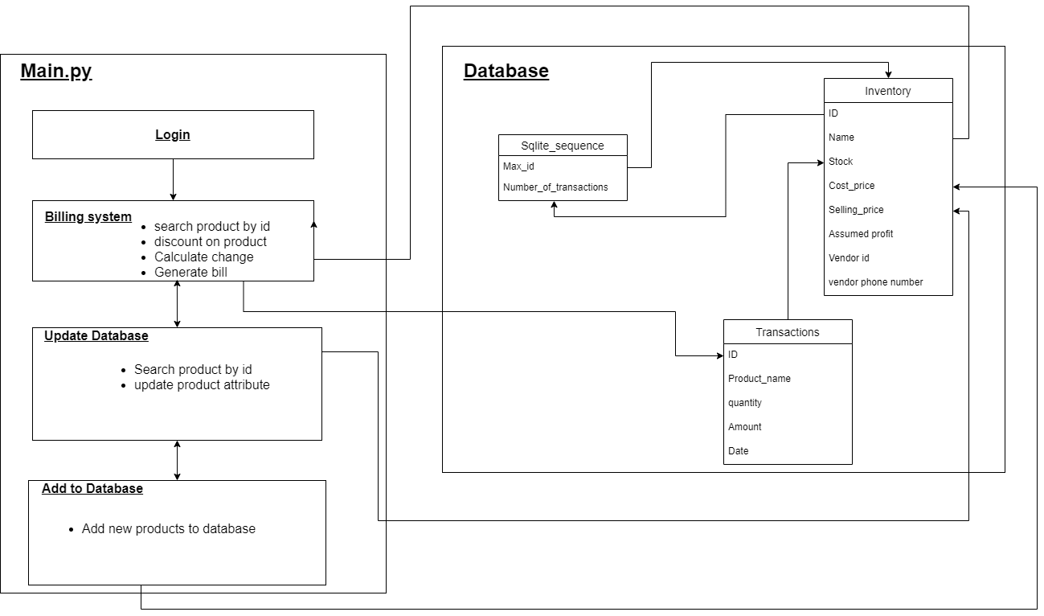



**SYSTEM DESIGN**

System Design is the most creative and challenging phase in the system life cycle. Design is the first step into the development phase for any engineered product or system. Design is a creative process. A good design is the key to effective system. System design is a solution how to approach the creation of a new system. System design transforms a logic representation of what is required to do into the physical specification. The specification is converted into physical reality during development.

**Logical design**

The logical flow of a system and define the boundaries of a system. It includes the following steps:

• Reviews the current physical system – its data flows, file content, volumes, frequencies etc.

• Prepares output specifications – that is, determines the format, content and Frequency of reports.

• Prepares input specifications – format, content and most of the input functions.

• Prepares edit, security and control specifications.• Specifies the implementation plan.

• Prepares a logical design walk through of the information flow, output, input, controls and implementation plan.

• Reviews benefits, costs, target dates and system constraints.

**Physical design**

Physical system produces the working systems by define the design specifications that tell the programmers exactly what the candidate system must do. It includes the following steps.

• Design the physical system.

• Specify input and output media.

• Design the database and specify backup procedures.

• Design physical information flow through the system and a physical design Walk through.

• Plan system implementation.

• Prepare a conversion schedule and target date.

• Determine training procedures, courses and timetable.

• Devise a test and implementation plan and specify any new hardware/software.

**4.2 Entity Relationship Diagram and Schema Diagram**

An entity relationship diagram (ERD) shows the relationships of entity sets stored in a database. An entity in this context is an object, a component of data. An entity set is a collection of similar entities. These entities can have attributes that define its properties.

There are two reasons to create a database diagram. You're either designing a new schema or you need to document your existing structure.

If you have an existing database you need to document, you create a database diagram using data directly from your database. You can save your bill details to .rtf file.

An ER diagram is a means of visualizing how the information a system produces is related. There are five main components of an ERD:

* Entities are represented by rectangles. An entity is an object or concept about which you want to store information.
* Weak entity is an entity that must defined by a foreign key relationship with another entity as it cannot be uniquely identified by its own attributes alone.
* Actions, which are represented by diamond shapes, show how two entities share information in the database.
* In some cases, entities can be self-linked. For example, employees can supervise other employees.
* Attributes, which are represented by ovals. A key attribute is the unique, distinguishing characteristic of the entity.
* A multivalued attribute can have more than one value. For example, an employee entity can have multiple skill values.
* A derived attribute is based on another attribute. For example, an employee's monthly salary is based on the employee's annual salary.
* Connecting lines, solid lines that connect attributes to show the relationships of entities in the diagram.
* Cardinality specifies how many instances of an entity relate to one instance of another entity.
* Ordinality is also closely linked to cardinality.

**Schema Diagram:**

**ER Diagram**

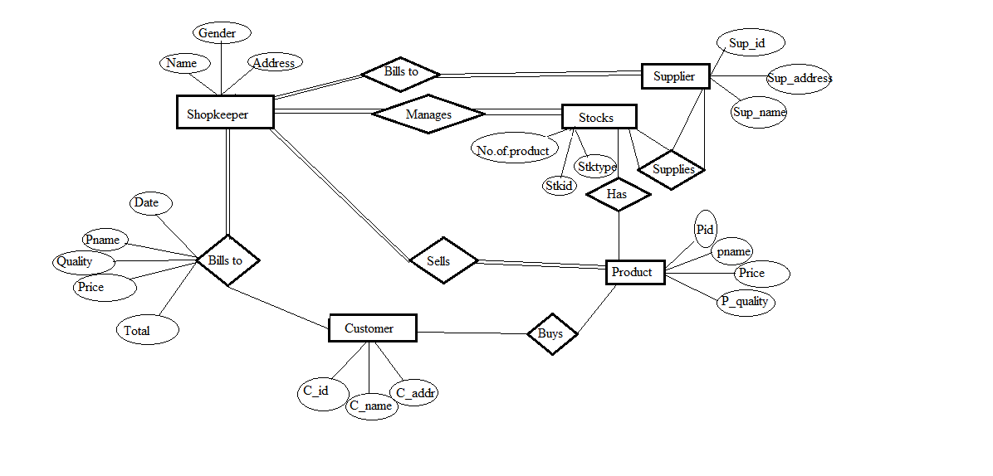

Chapter 5:

SNAPSHOTS AND DISCUSSIONS

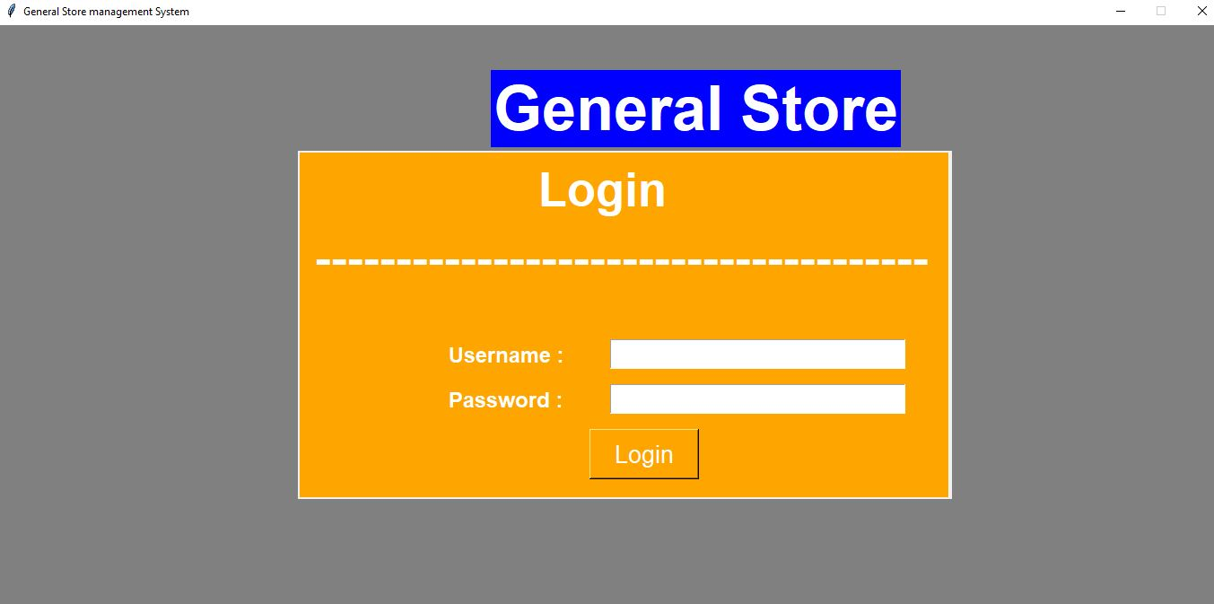

**Figure 5.1: Admin Login page**

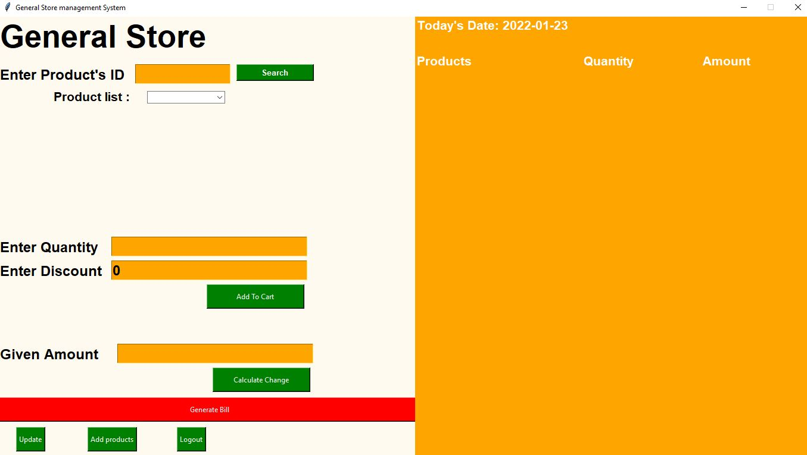

**Figure 5.2: Main billing page**

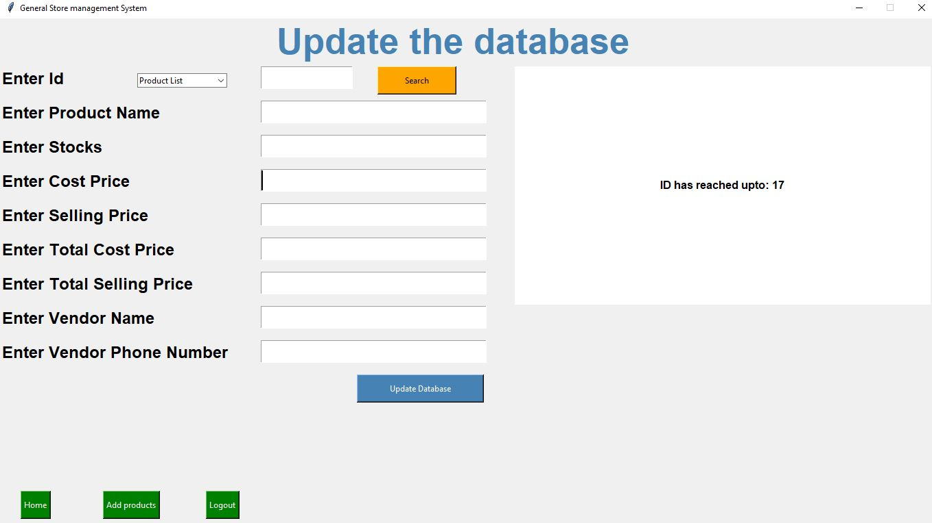**Figure 5.3: Update Page**

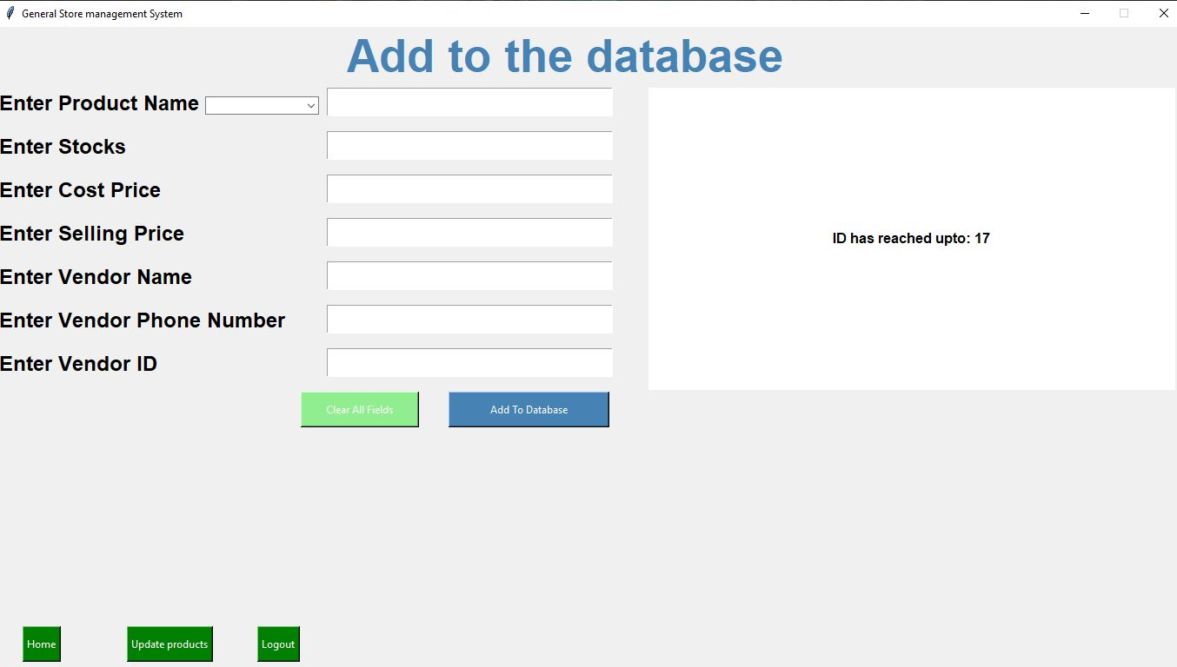**Figure 5.4: Adding Page**

**Chapter 7**

**CONCLUSION**

We have been given the problem of automating the material of stores . Earlier the materials of stores have only been automated. In our project **“GENERAL STOREMANAGEMENT SYSTEM ”** we have automated the stores

In Issues module, we have tracked the information regarding the issues of the receipts for the material that have been stored in the store This information can be easily made available to all the stores throughout the internet

As a result of this automation, manual workload is reduced and data retrieval becomes easy. This project can be helpful for automating the managing of general stores.

**Chapter 7**

**BIBLIOGRAPHY**

**References:**

[https://docs.python.org/3/library/tkinter.html](http://www.mysqltutorial.org/)

https://www.python-course.eu/

https://stackoverflow.com/questions

https://www.tutorialspoint.com/python/

https://www.geeksforgeeks.org/python-gui-tkinter/

https://www.javatpoint.com/sqlite-tutorial

https://www.sqlite.org/index.html

**CODE:**

**SQL Commands for Table Creation:**

CREATE TABLE inventory(id INTEGER PRIMARY KEY AUTOINCREMENT,`name` TEXT,stock INTEGER,

cp INTEGER,

sp INTEGER,

totalcp INTEGER,

totalsp INTEGER,

assumed_profit INTEGER,

vendor TEXT,

vendor_phoneno INTEGER)

CREATE TABLE transactions (

id INTEGER PRIMARY KEY AUTOINCREMENT,

product_name TEXT,

quantity INTEGER,

amount INTEGER,

date date

)

CREATE TABLE CUSTOMER(cname char(10) not null, cid varchar(5) primary key, caddr varchar(20) not null)

CREATE TABLE PRODUCT(pid number(2) primary key,pname char(10) not null, price real not null.)

CREATE TABLE SUPPLIER(sid number(5) primary key,sname char(10) not null, vnum number(10) not null)